Comparable Sale | Sale No. 1
Property Type | Restaurant and Bar
CAD ID: | 00210137
Street Address: | 444 Keller Parkway
City: | Keller
State: | Texas
County: | Tarrant
Land Size (SF): | 18000
Land Size (Acres): | 0.413
Gross Building Area (SF): | 2500
Net Rentable Area (SF) | 2500
Finish-out Percentage | 100%
Land to Building Ratio: | 7.20
Year Built/ Renovated | 1945
Date of Sale: | 2/18/2026
Sales Price: | $675,500
Unit Price ($/Net SF): | $270.20
Unit Price ($/Gross SF): | $270.20
Occupancy Rate at Time of Sale: | 100%
Data Source: | North Texas MLS 20882100, North Texas MLS 20882100, Tarrant CAD
Recorded Number: | Not available yet
Grantor: | Manny And Pam LLC
Grantee: | Not available yet
Terms and Conditions: | Cash or conventional financing
Time on Market: | 310
Property Rights Conveyed: | Fee Simple
Transactional Status | Sold
Original Listing Price: | $1,100,000
Sale-to-List Ratio: | 61%
Additional Comments: | This was a Restaurant and Bar at time of sale. Recent renovations include parking lot, roof, HVAC, plumbing and electric. This property has an outdoor deck area.

Improved Comparable Sale No. 1
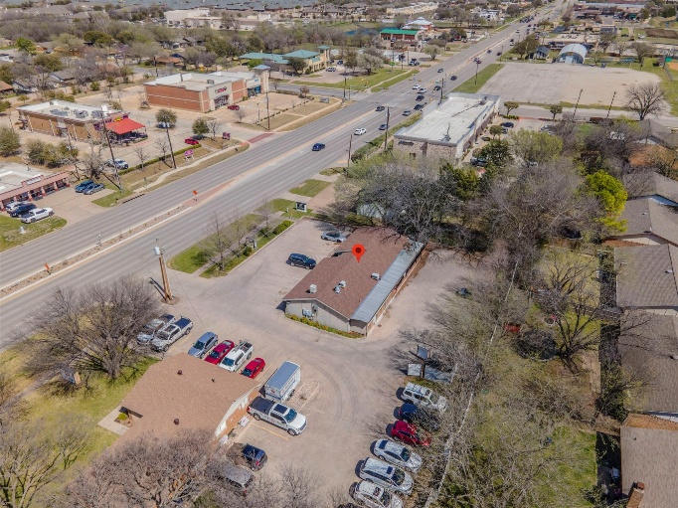 | 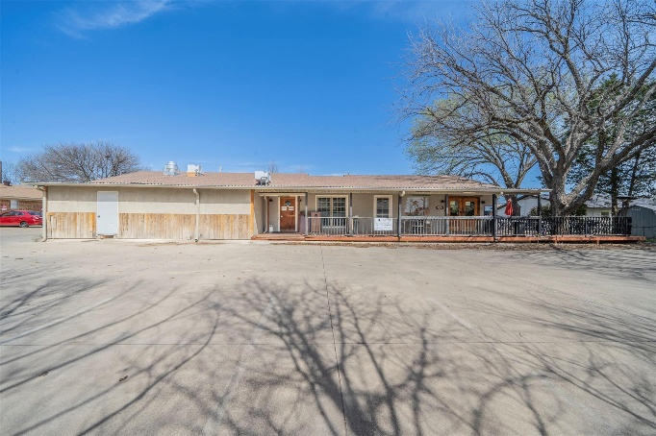
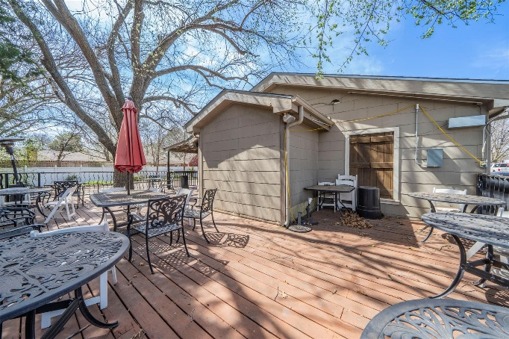 | 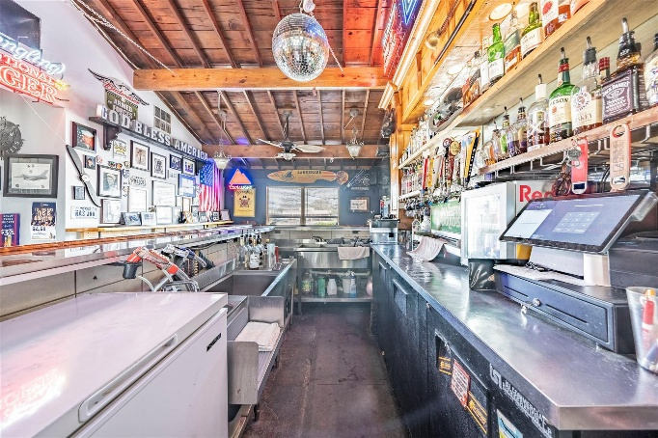
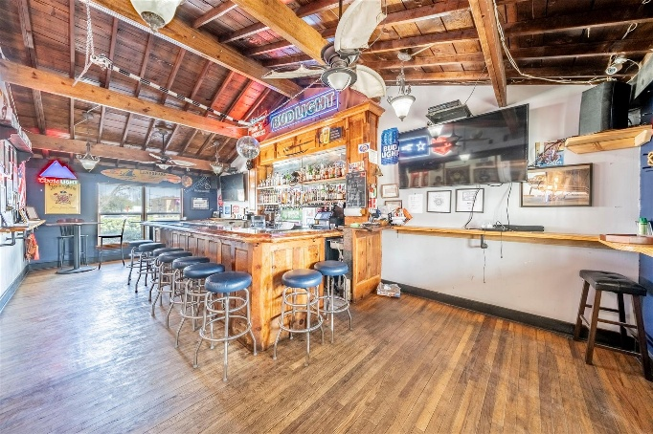 | 